IT24102605

Punchihewa S.D

Exercise

1)

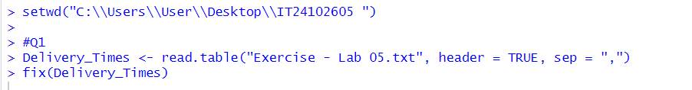

2)

3)



4)

